Absence:

1. -- Count of students by absence code

select a.AbsenceCode,a.AbsenceCodeDesc,count(c.StudentID) as no_of_students

from dimAbsenceCode a

JOIN

factAbsence b

ON a.AbsenceCodeID = b.AbsenceCodeID

JOIN

dimStudent c

ON b.StudentID = c.StudentID

GROUP BY a.AbsenceCode,a.AbsenceCodeDesc

order by count(c.StudentID) desc

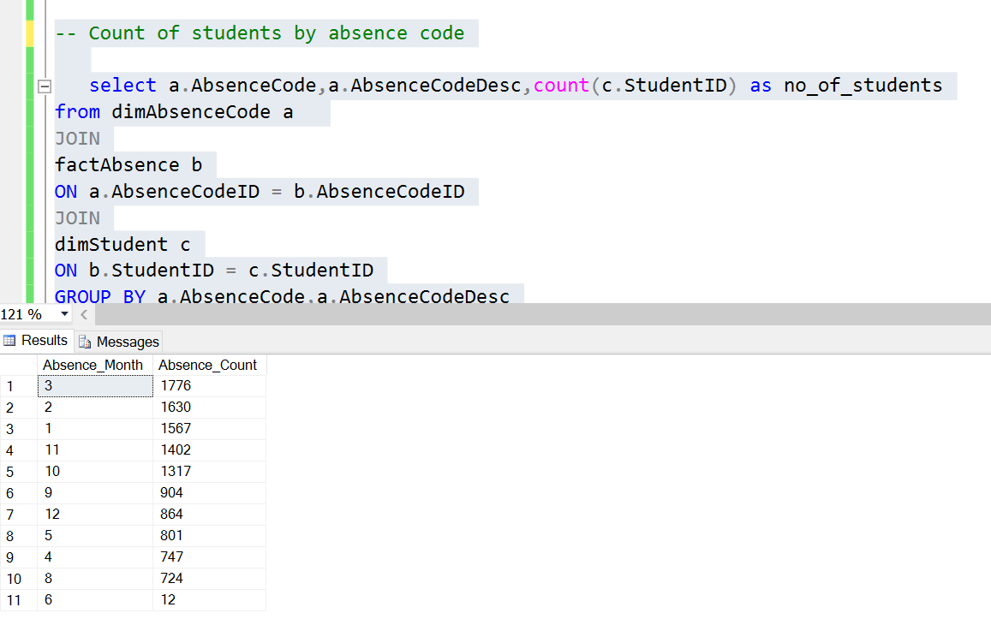

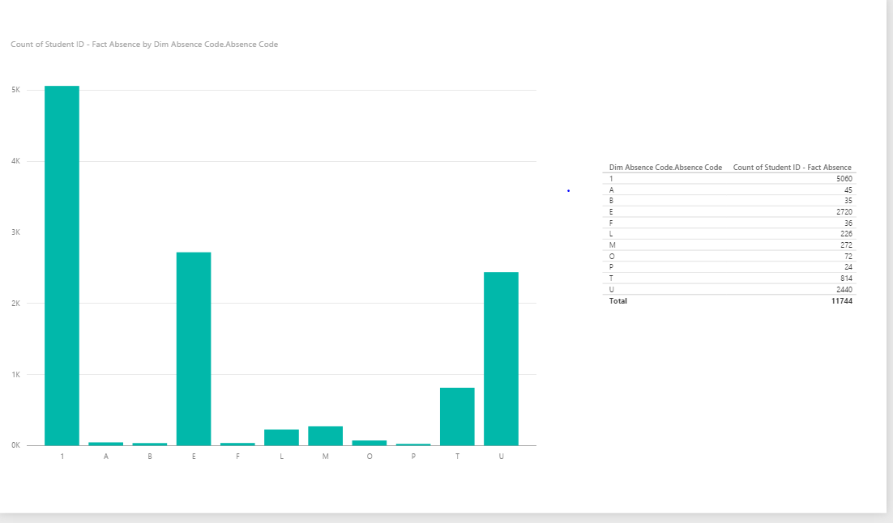

-- 4 Which month has the highest absence rate

select DATEPART(m,a.AbsenceDate) AS Absence_Month,count(a.AbsenceID) AS Absence_Count

from

factAbsence a

group by DATEPART(m,a.AbsenceDate)

order by count(a.AbsenceID) desc

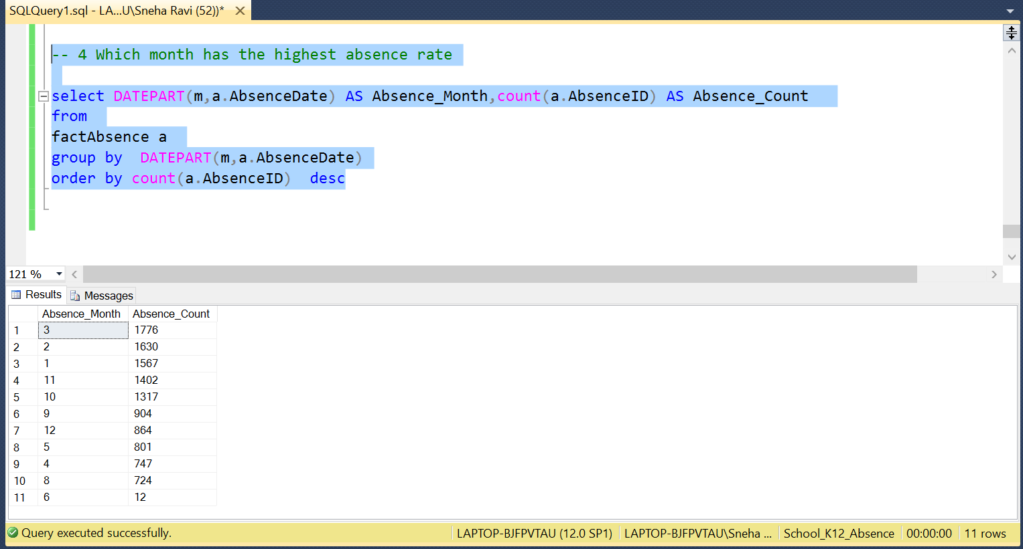

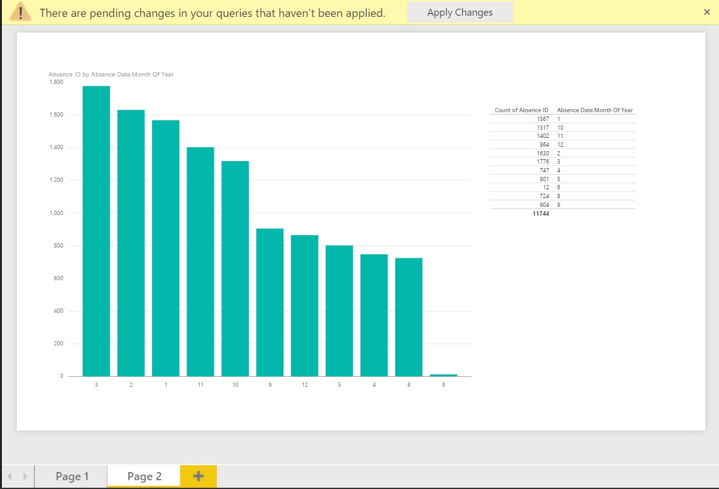

DIM